Project Weekly Progress Report  
Agile – Scrum

|  |  |
| --- | --- |
| Semester | Fall-2024 |
| Course Code | AML2404 |
| Section | Section 2 |
| Group Name | Group 4 |
| Student names/Student IDs | Meher Vamsi Dontoju - C0893004​  Rudraksh Bahri - C0891302​  Sarveswararao Patchipulusu - C0892924​  Tazeen Singh Sudan - C0891287 |
| Reporting Week | Week - 3 |
| Team Lead for the reporting week | Tazeen Singh Sudan |

# **Progress Made in Reporting** **Week**

Introduction:

This report provides an overview of the progress made and the challenges encountered during the past week in our project to develop a restaurant recommendation chatbot. The primary focus of this week's work has been on data acquisition and establishing a project repository on GitHub.

1. Data Acquisition

One of the key components of our chatbot is to provide users with restaurant recommendations based on their preferences. To accomplish this, we need access to two types of datasets: menus from various restaurants and conversations between users and chatbots. This week, significant progress has been made in this area:

a. Menu Dataset

We have been actively searching for a valid dataset containing menus from different restaurants. This dataset will serve as the foundation for our chatbot to provide detailed information about the cuisines and dishes available at various eateries.

b. Conversation Dataset

Simultaneously, we have been searching for a dataset that includes conversations between users and chatbots. This dataset will be used to train our chatbot's natural language understanding and generation capabilities.

c. Web Scraping

To acquire the menu data, we have begun exploring web scraping techniques to collect menu information from various restaurant websites. This approach will enable us to ensure a wide variety of cuisines and dishes in our chatbot's knowledge base.

2. GitHub Repository:

In addition to data acquisition efforts, we have established a dedicated GitHub repository for our project. This repository serves as a central hub for collaboration, version control, and project documentation. We have made the following progress in setting up the repository:

Created the project repository on GitHub, providing a structured environment for code and documentation.

Initialized the repository with essential project files, including README.md, which outlines the project's objectives, setup instructions, and contribution guidelines.

Invited team members to join the repository, facilitating collaborative development.

Minimum Viable Product:

This end-product includes the following features in the initial phases. As we approach towards the end we will include more of the features. The initial features include:

1. Place new order
2. Track order by order id
3. Add order
4. Remove order

Scope of the project:

The above-mentioned features are the scope of the project (SOW).

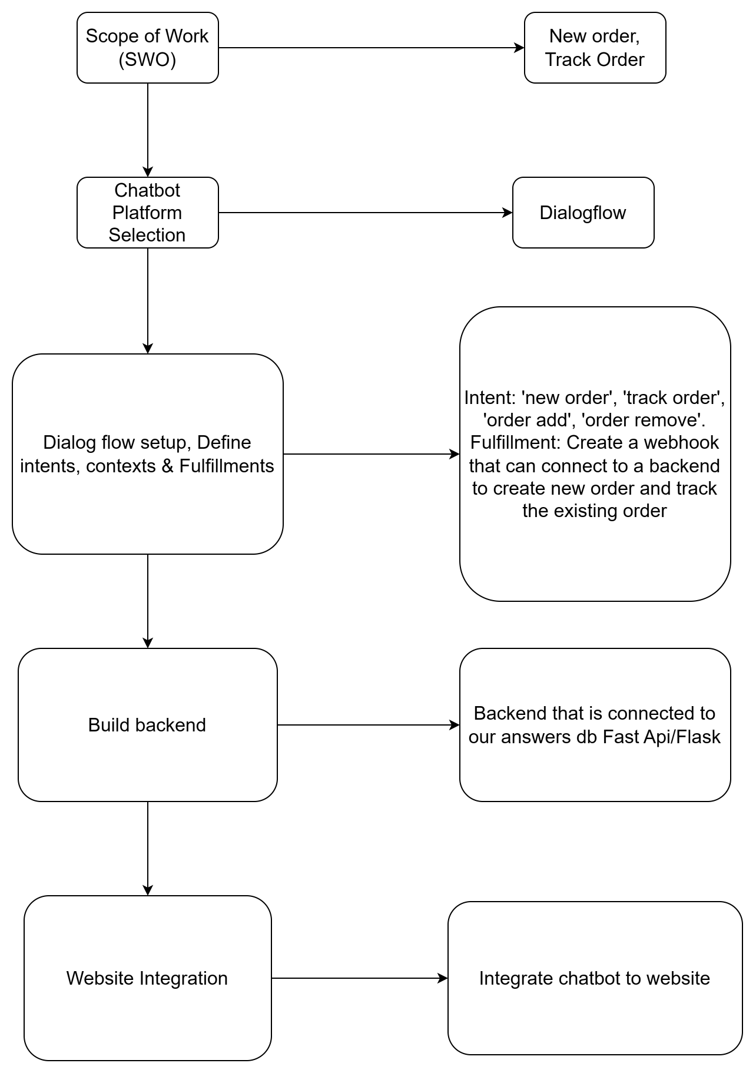

Fig 1: Flowchart of our project design

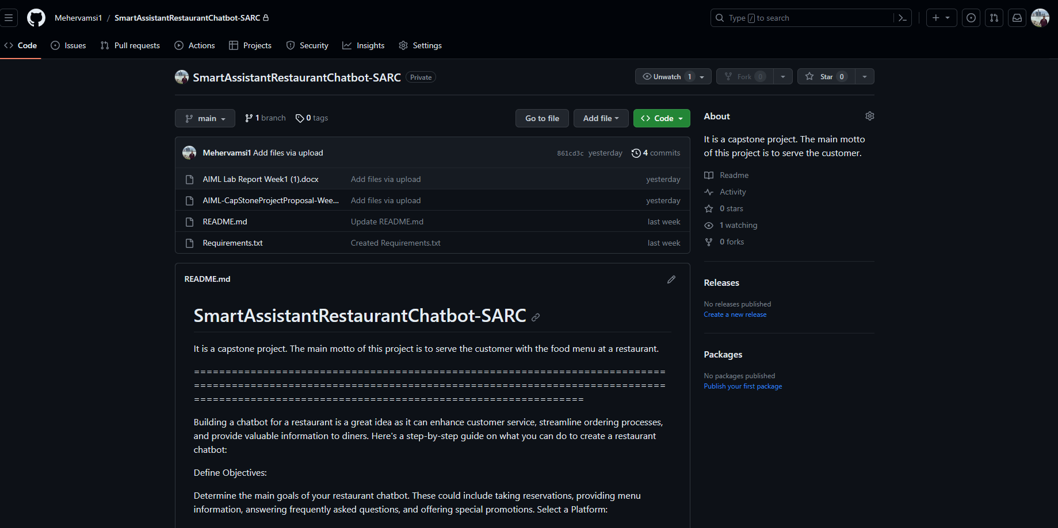

Fig 2: Snapshot of the GitHub Repository.

Platform Selection:

In our quest to find the most suitable platform for our chatbot development, we diligently researched options like Dialogflow and Rasa. We have thoroughly analyzed and compared their features, capabilities, and overall suitability for our project. This research has culminated in a detailed table outlining the key differences between the two platforms.

After careful consideration, we have made a decision to move forward with Dialogflow as our preferred chatbot development platform. This choice is based on the platform's robust natural language understanding (NLU) capabilities, extensive integrations, and user-friendly interface, which align closely with our project's requirements and goals.

Dialogflow's proven track record in delivering efficient and scalable chatbot solutions makes it the ideal choice to power our restaurant recommendation chatbot. With this decision in place, we are now poised to leverage Dialogflow's features and capabilities to drive our project forward, ensuring a successful and user-friendly chatbot experience.

|  |  |  |
| --- | --- | --- |
| Feature | Dialogflow | Rosa |
| NLP Capabilities | Offers powerful NLP capabilities out of the box | Provides customizable NLU and NLP pipeline |
| Training Data | Relies on Google’s vast training Data | Requires manual training data creation |
| Platform | Cloud-based solution | Open-source framework |
| Customization | Limited customization | Highly Customizable |
| Integrations | Provides easy integrations with various platforms | Offers limited easy integrations |

Table 1: Comparison between Dialogflow and Rosa

# **Difficulties Encountered in Reporting Week:**

Despite the progress made, several challenges have arisen during the week:

1. Data Availability

Menu Dataset: Finding a comprehensive and up-to-date dataset containing menus from various restaurants has proven to be more challenging than anticipated. Many sources either do not provide structured data or have outdated information.

Conversation Dataset: Locating a suitable conversation dataset for training our chatbot has also been a challenge. High-quality, large-scale datasets with diverse user interactions are not readily available.

2. Web Scraping Complexity

While web scraping shows promise for menu data acquisition, it comes with its own set of challenges. Websites may employ anti-scraping measures, making it necessary to devise robust scraping strategies. Additionally, data cleaning and formatting are required to ensure the extracted data is usable.

References:

[1] Stephanie (2020, July 30). Top 7 requirements for chatbot software. *ONLIM.* <https://onlim.com/en/top-requirements-for-chatbot-software/>

[2] Daryna L. (2022, December 1). Chatbot requirements Technical & Non-Technical to consider. *BotsCrew.* <https://botscrew.com/blog/essential-chatbot-requirements/>

[3] Ivy.ai. A Guide for developing AI Chatbots for Higher Education. *Ivy* <https://go.ivy.ai/hubfs/Marketing/Handouts%20and%201%20Pagers/Example%20AI%20%20Chatbot%20Requirements.pdf>

[4] Steven B., Ewan K., and Edward L. (2009). Natural Language Processing with Python. *O’Reilly Media Inc.* <https://www.nltk.org/book/>

[5] Python/C API Reference Manual. Python Software Foundation. <https://docs.python.org/3/c-api/index.html>

[6] Google Cloud. Dialogflow Documentation. *Google.* <https://cloud.google.com/dialogflow/docs>

[7] Rosa. Rosa Documentation. *Red Hat.* <https://docs.openshift.com/rosa/welcome/index.html>